May.2013

Clarify CDS

User Guide

Clarify
User Guide
ENG

Table of Contents
1.0 Introduction 3
1.1 Specifications 3
1.1.1 System Requirements 3
1.1.2 CDS Main Specification 3
1.2 Installation 4
1.2.1 Installation 4
1.2.2 Uninstall 4
1.3 Clarify Files and Directories 5
1.3.1 Single Needle (*.SS) 5
1.3.2 Instrument Configuration(*.INC) 5
1.3.3 Spectra Processing (*.CP) 5
1.3.4 Spectra (*.CDF file) 5
1.3.5 Calibration Curve(*.CAL) 5
1.3.6 LOG file (*.LOG) 6
1.3.7 Report style files (*. STY files) 6
2.0 Spectra operate Mode 6
2.1 Zoom in 6
2.2 Zoom out 6
2.3 Drag 6
3.0 Introduction 6
3.1 Five system icons 7
3.2 User Account 7
3.3 System Configuration 8
4.0 Audit 11
5.0 Report style 12
6.0 Data Acquisition 13
6.1 Data Acquisition 13
6.2 Spectra processing 16
6.3 Introduction of Menu Bar 16
6.4 Spectrum 18
6.5 Calibration 28
6.6 Menu Introduction 29
7.0 Calibration Curve Made Procession 30
7.1 ESTD 30
7.2 ISTD 32
8.0 Report 33

1.0 Introduction

Thank you for buying Company Clarify Chromatography Data System, in order to ensure your proper operation, please read this manual carefully, it has introduced the main performance and technical indicators, installation, unloading, debugging, and operation example, etc. If has any other questions, please contact with us for the timely answer.

Any product has shortcomings, our product is not exceptional. Please contact with us if you have any suggestion. Please contact us for improving the service.

1.1 Specifications

1.1.1 System Requirements

Hardware Computer
CPU: 166 MHz or faster
Memory: 32M Bytes or more
Disk Drive: 1 hard disk, 1 CD-ROM drive
USB: 2 port
Monitor: VGA display and graphics card
256 colors, 1024 by 768 pixels
Software Windows: Microsoft Windows 98/2000/XP/VISTA/WIN7 or later
Internet Explorer 4.0 or later

1.1.2 CDS Main Specification

General
Number of Channels: 2
Input Voltage: -2.5V ~ 2.5 V
Input Resistance: > 10 MΩ
Sensitivity of Integration: 1 u V/s
Minimum resolution: 1 u V
Dynamic Range: 10⁷
Linearity: ±0.1 %

Peak Processing
Number of peaks: > 1000
Width of peak: 0.01 s
Automatic Time Programming
Manual Integration enabled
Automatic identification of complex peaks and precise partition of overlapped peak
Automatic tracing and correcting base line
Automatically eliminate the affect of negative peak
Meet the GMP regulation

Methods for Identifying Peak
Conservative time method
Components table method

Parameters for Integration
Peak area
Peak height

Method for Quantitative Calculation
1. Normalized Method,
2. Normalized Method with Proportional Factor,
3. Internal Standard Method,
4. Grouping Method,
5. Multiple Internal Standard Method,
6. External Standard Method,
7. Logarithmic Method.

1.2 Installation

1.2.1 Installation

Before installation, please check if there is NET 2.0 Platform, if not, click the System File in CD, double click to set up.

Double click set up, choose the save path, then click “ Next” to finish, if install in C, you should make folder in C.

1.2.2 Uninstall

Click the in folder to uninstall, please save the data to avoid lost before uninstall.

1.3 Clarify Files and Directories

1.3.1 Single Needle (*.SS)

Single needle is a workstation for chromatograph signal acquisition sequence. Involves saving path, sample number, condition, file name, acquisition time, equipment configuration files, spectra processing files and so on. Single needle is saved as a * SS File, can be directly opened to use before sampling.

1.3.2 Instrument Configuration(*.INC)

Instrument configuration is the record of the experiment information, such as chromatographic column, mobile phase, flow and external control use, acquisition frequency. Counteraccusation version can also set the pump flow, gradient, pressure and the wavelength of the detector, etc. Save as *. Inc can be used under the same equipment configuration condition.

1.3.3 Spectra Processing (*.CP)

Clarify can export the integrals, result and performance of spectrum figure through spectrum diagram window, method can be used the CP files. In the single needle file loading spectra can be used quickly.

1.3.4 Spectra (*.CDF file)

Clarify use the most universal CDS *.CDF file format, AIA of other CDS file format can be also imported.

1.3.5 Calibration Curve(*.CAL)

Calibration curve which is made under the calibration window, include external standard method or internal standard method. Concentration, system suitability can be calculated by the calibration file.

1.3.6 LOG file (*.LOG)

LOG file is used to record the CDS running, such as open, close and sampling, etc. LOG file can be formed every day by the name of date.

1.3.7 Report style files (*. STY files)

Clarify Report style can be set in the main window, all the report style is saved as
*. STY file

2.0 Spectra operate Mode

2.1 Zoom in

Hold the left mouse button in the spectra window from left to right, the selected area will be enlarged after let it go.

2.2 Zoom out

Hold the left mouse button in the spectra window from right to left, the selected area will be the whole spectra after let it go.

2.3 Drag

Hold the right mouse button in the spectra window, the other part of spectra can be shown in the window.

3.0 Introduction

Main Window
Clarity Main Window include acquire, calibration, spectra, system and else buttons, click the relevant module to operate.

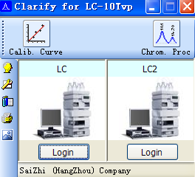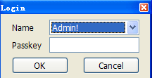
Input the Name and Passkey to login in.

3.1 Five system icons

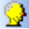 | User Account | Set visit permissions and password especially administrative user account
 | Configuration | Set the configuration of the instrument.
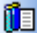 | Audit | Shows the selected records of the mission and set their logs
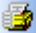 | Report Style | Edit the report, set the report style.
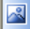 | About | Information such as the version on CDS, ownership and else.

3.2 User Account
Click 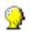, the window below will show you the dialog box.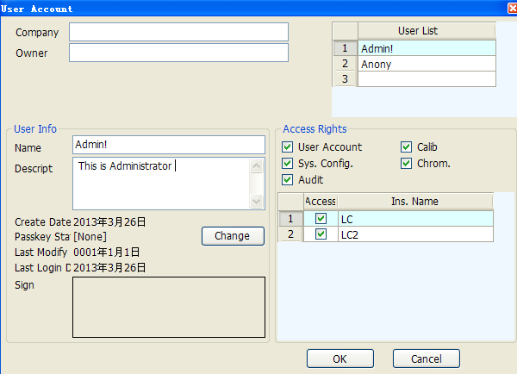

Click the sign area, you can choose the electronic signature, support *.JPG Format, which will be shown on the right below corner of report.

Access area can edit the different permission of different account, only authorized account can check and edit the contents.
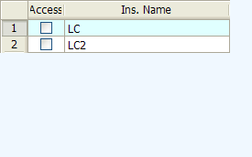

3.3 System Configuration

Click in main window, the dialogue box will be open as below.
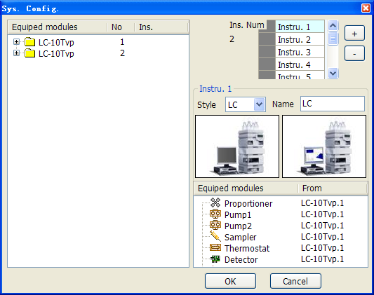

Connect with devices:
Countercharge will be realized after successfully connected the CDS with devices. Double click 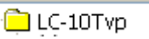, below window will open, click Connect, when “2239” appear, open the channel, channel lamp will be green flashing.
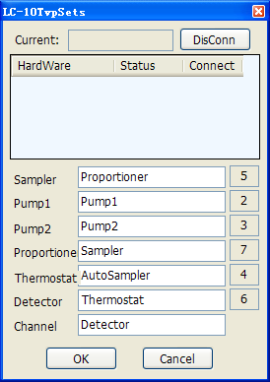
Before connect After connect

Choose the needed device, click right mouse botton——Equip to instru.
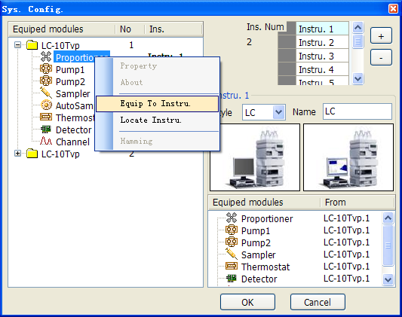
Ins. Num: It display the total number of instruments, click 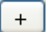, the number will add 1. The instruments in main window will be added as below, click , the number will be decreased.

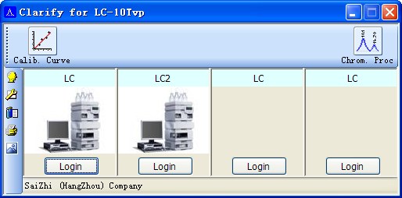

Instrument: Choose instrument as below, such as below：
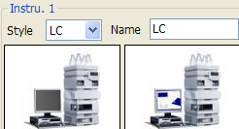
Instrument Style can be choosed in the menu, name can be changed.
Click instrument image, the image can be exchanged.

4.0 Audit
Audit window is used for record the operation of CDS, account who has the right can view，click 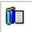 to log in.
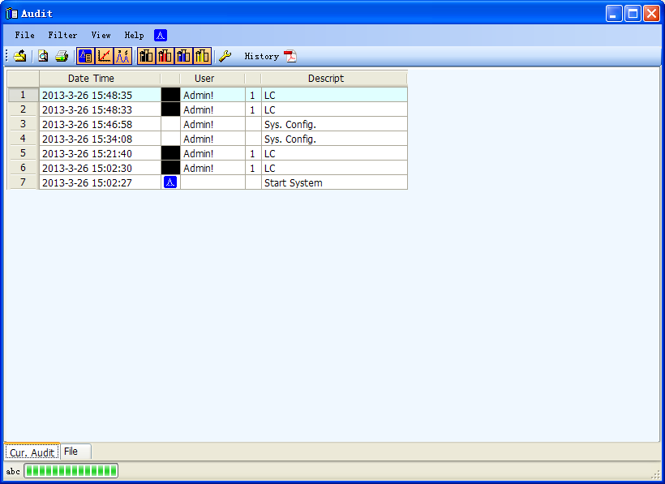
Click , below window will be shown,
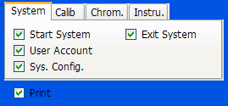
History: When the icon appear, the file has been saved as pdf. Double click , file can be viewed. The files are in the Document of Audit folder.
How to convert to pdf? Click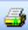, the print window will be shown, choose Microsoft XPS Document Writer, click Print, input the file name to save.

5.0 Report style
Click , set up the report style in the below window,
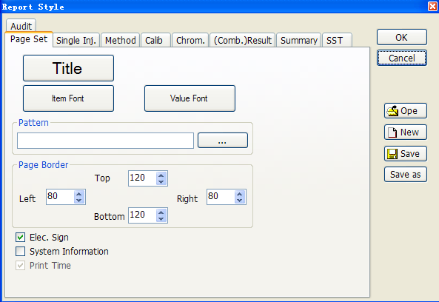
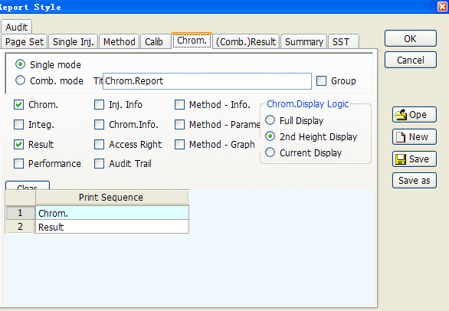

6.0 Data Acquisition

6.1 Data Acquisition
Data acquisition is used to collect the signals of the instrument, which can be get in the login window.
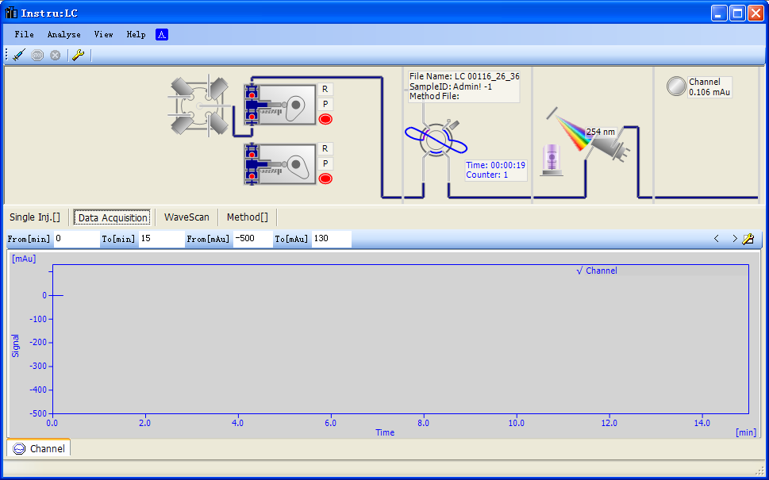

Pump specification can be modified in the below window:
Four Unit can be choosed, include MPa，kfg/cm，bar，psi.
1MPa=10⁶Pa=10bar=145.03psi
1 bar=10⁵Pa =14.503psi
1psi=6.895kPa=0.0689476bar

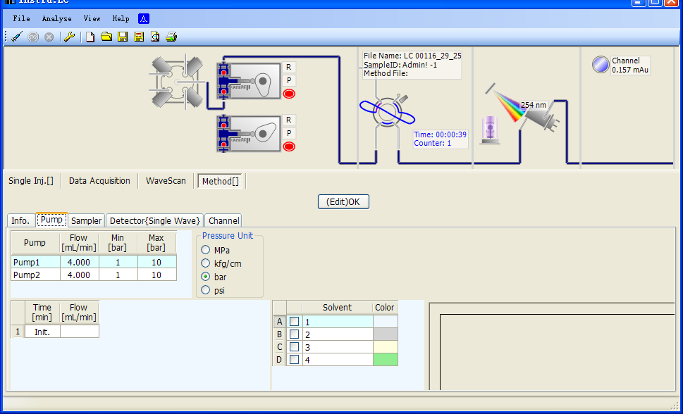

Double Click the below area can changed the solvent color, the corresponding color will be shown according to the proportion.
Channel Lamp:
Blue: Open the CDS
Green: Connect to instrument
Note: if the color turned to blue in the process of running, please check the connection of CDS and PC, or check the system specification if OK from the main window.

File: click to open the below window for setting.
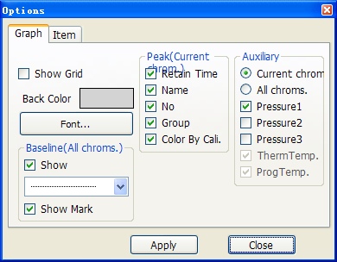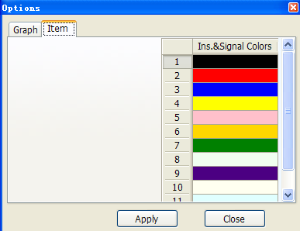

Analysis:
Start to run
Stop to run
Quit without save

6.2 Spectra processing

After data acquisition, open the spectrogram, CDS will automatically identified the chromatogram peak. Click on the main window "Chrom proc" icon to enter like below:

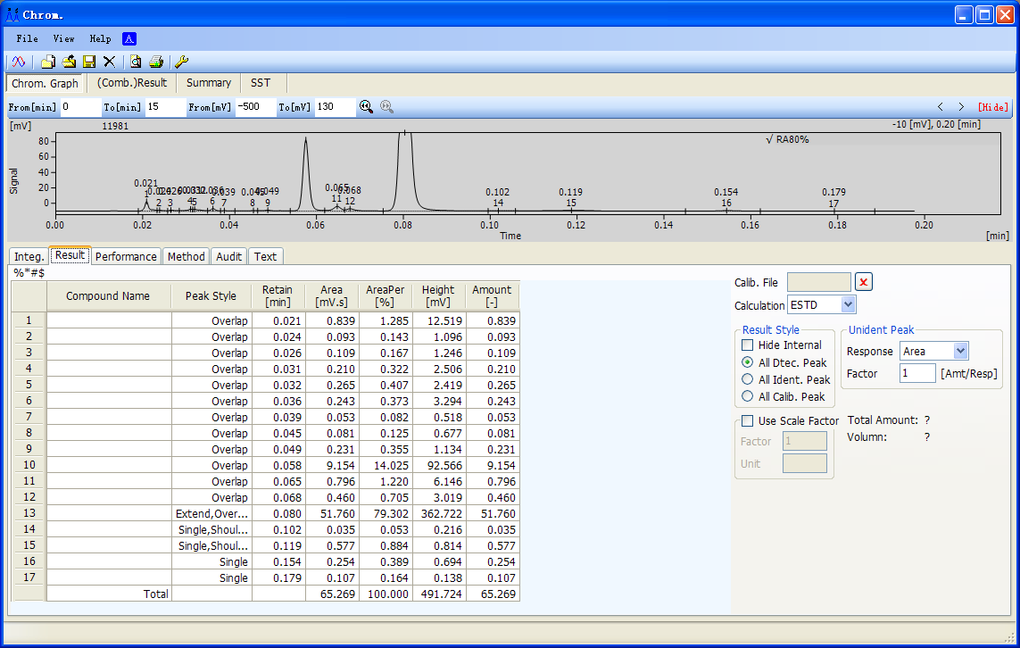

Note: For large data spectrogram, open will cost longer time.

6.3 Introduction of Menu Bar
File
File Browser Click , file name will appears at the left side of window; double click can open the spectrogram.
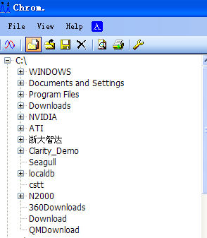

Overlay Mode Choose , multiform spectrograms can be opened.
Open *.cdf or *.dat（N2000）style spectrogram file can be opened.
If open *.dat（N2000）file, below window will be appear: Frequency can be set up by clients.
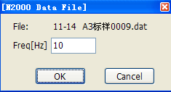

Close
Save
Export *.CDF, *TXT, *.CP, *.WMF can be exported, the files will be in the file of “Export”, the spectrogram can be output in the Word and Excel.

Apply. AP File Spectrogram can be displayed in the CP file.

Exit Exit the spectrogram window
Preview
Print

Options

6.4 Spectrum

Hide the below table
Switch Pressure, Temperature

Spectrum graph window size is adjustable, move the mouse to the interface of the spectra and the results table, the mouse into a , at this time hold the mouse
Can adjust the size.

Hold the left mouse button drag from left to right, spectra can be amplified, from right to left shows full spectrum diagram, Hold down the right mouse button, spectra can be moved.

Integ. Intergal Table display the min. peak width and the peak height.

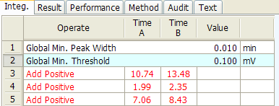
Red color shows integral failure, does not meet the requirements for the integral.
Right Click or by “Delete” on keyboard can delete the integral.
Four rows on the right can do the integral by hand.
Detector delay
Manually select or input lag time value, spectra will be left or right offset by the input value time range, positive to left, negative to the right.

Global minimum peak width
Set the minimum peak width, smaller one will not be identified.

Global minimum peak height
Set the minimum peak width, smaller one will not be identified.

Negative peak detection

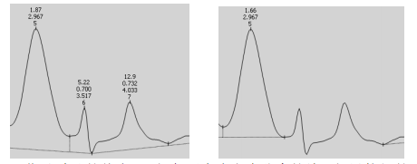

Shoulder cut area ratio
The default value of CDS is 3, two incompletely separate peak, if their area ratio
is more than 3, it was identified as shoulder peak, if less than 3 will be identified as overlapping peak.

Shoulder cut slope ratio
The default value is 2.5, two incompletely separate peak, if their slope is bigger than 2.5, it was identified as overlapping peak, if less than 3 will be identified as shoulder peak.

Add positive peak
Add positive peak within the selected scope
Added Result

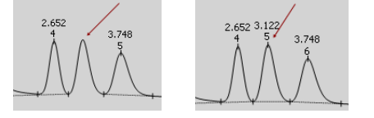

Add negative peak
Add negative peak within the selected scope
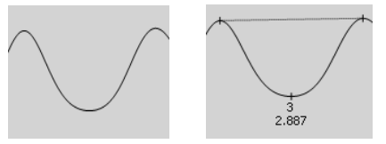
Seperation
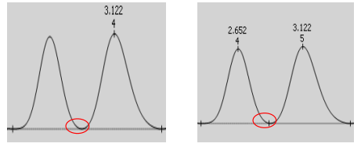

According to the requirements two kindes can be choosed, automatic adjustment and unchanged baseline.

Baseline will be adjusted automatically after delete one peak.
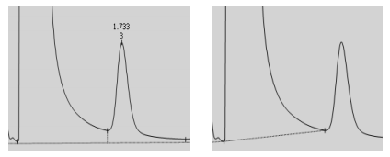
Baseline will not be changed
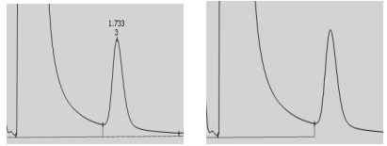

Delete peak
Delete Result
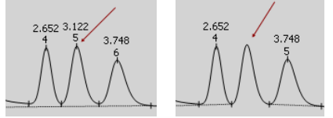

Set smallest peak width
Set smallest peak height
Set smallest half peak width
Set smallest peak area
Valley point Add or change the original valley position within a certain range
Make baseline across the valley point, adjust peak (group) to be single peak
Integration baseline, adjust the peak (group) as the overlapping peak
Adjust peak (group) the baseline level to be forward
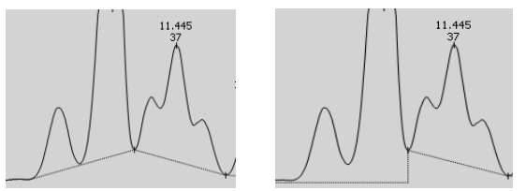

Adjust peak (group) the baseline level to be backward

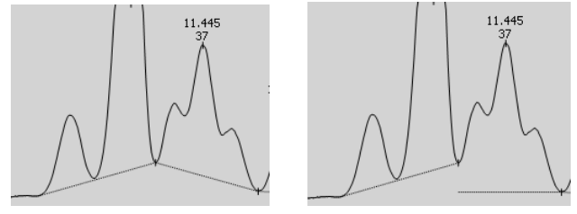
Before cut sets
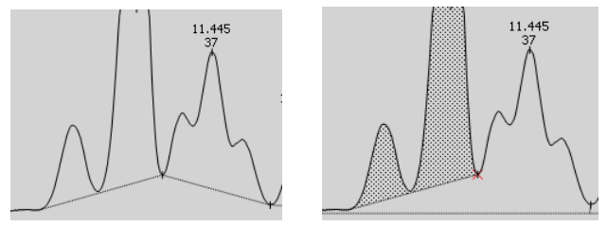
Tail cut
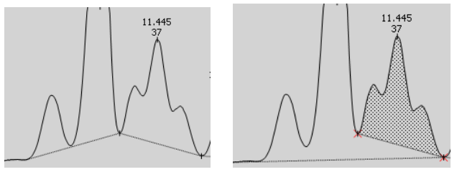
Solvent peak
Group peak
Result
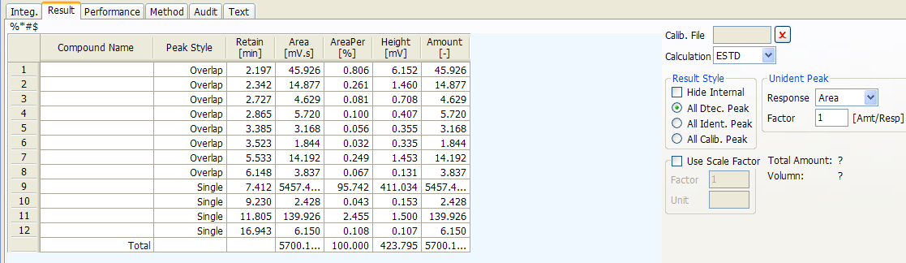
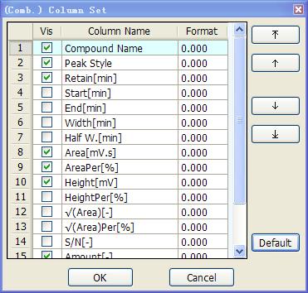
Calib. File: Calib File can be choosed in the space, which can be made in Calibration.
Performance: All data here is calculated by the EP, 50% of peak width.
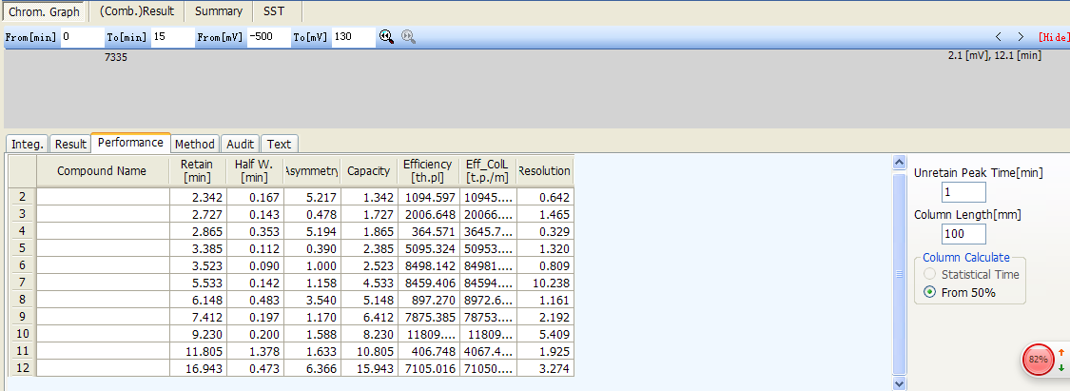

Right click can choose the items below:
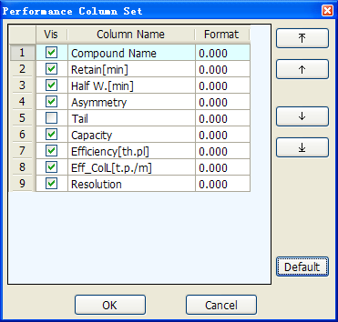

Method:
The system specification can be choosed before collect data, please make sure all information has been confirmed.
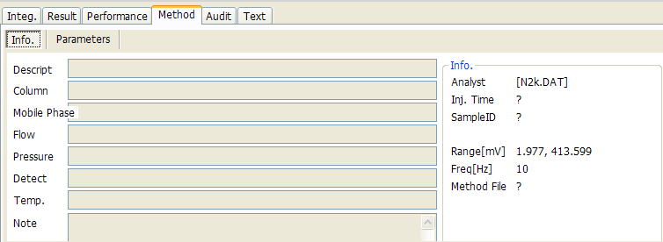
Audit: All the operation on spectra will be recorded here to ensure the authenticity.
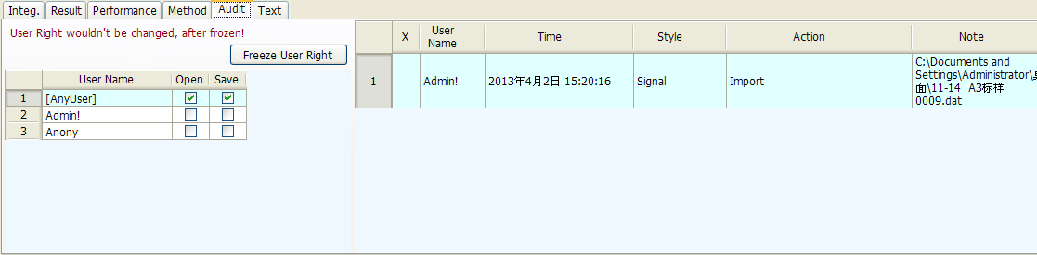

User permission can be set on the left side.

Text: Include all the spectra information, such as run time, end time, peak height and area and other information.

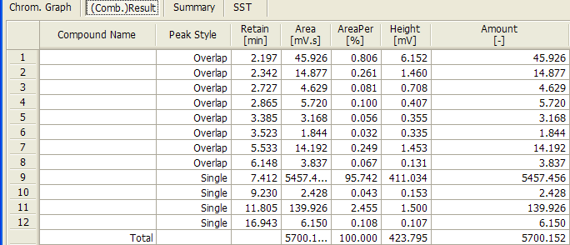
(Comb.) Result: This table includes all the results information.
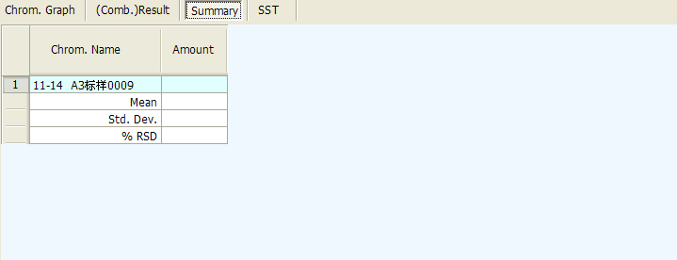
Summary: When open two or more than two spectra, input the same Chrom.Name in every spectra, or load the calibration file, the same Chrom. Average (Mean), RSD (Std. Dev.), %RSD will be displayed in the summary.
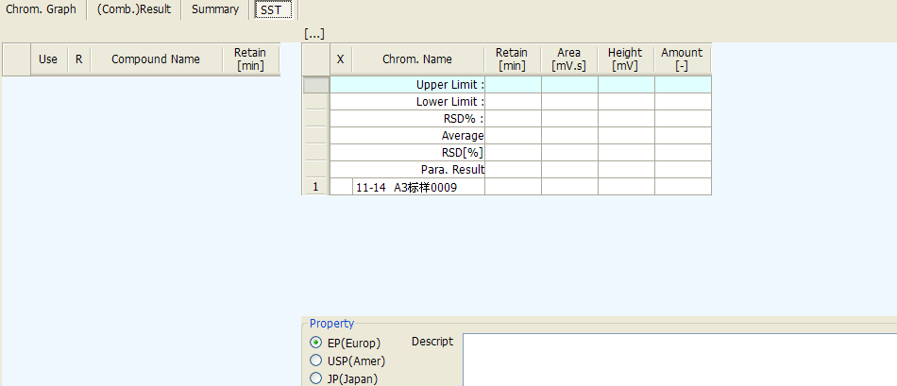
SST: To verify the chromatography system based on the chromatographic evaluation. Load the files at the opend spectra, components will be refreshed in the calibration file.

SST Making Procession
Open the spectra, load the calibration files. Click “SST”, below window will be displayed.
Click the Use of every compound in the left, input the limit value and the RSD%, CDS will calculated and judged.
Red color means overpass the limitation, Blue color means no judgement without limitation value, others is black.
Save as *.SST file after edited.

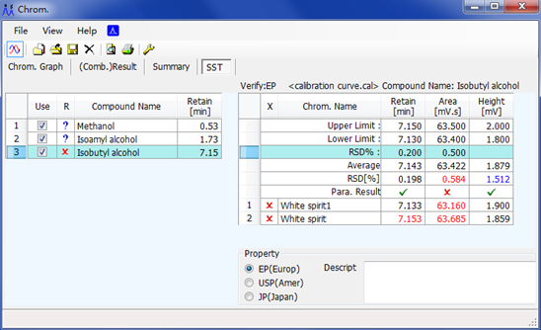
Without limitation value
All parameters are qualified
Parameters are more than the given limitation.

6.5 Calibration

Open the calibration window as below:

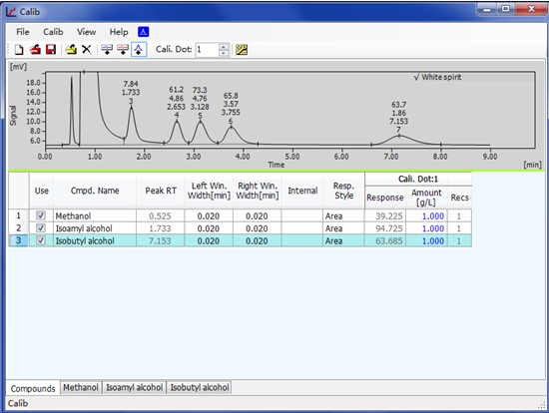

6.6 Menu Introduction
Files
New |  | New calibration curve
Open |  | Open calibration curve
Save |  | Save calibration curve
Save as |  | Save to another files
Open Std. |  | Open the standard spectra which used for made calibration curve
Close Std. |  | Close the opened standard spectra
Preview |  | Preview the calibration curve
Print |  | Print the calibration curve
Close |  | Close the calibration wincow

7.0 Calibration Curve Made Procession

7.1 ESTD
Open the first spectra, click add all the peaks , input the compound name,
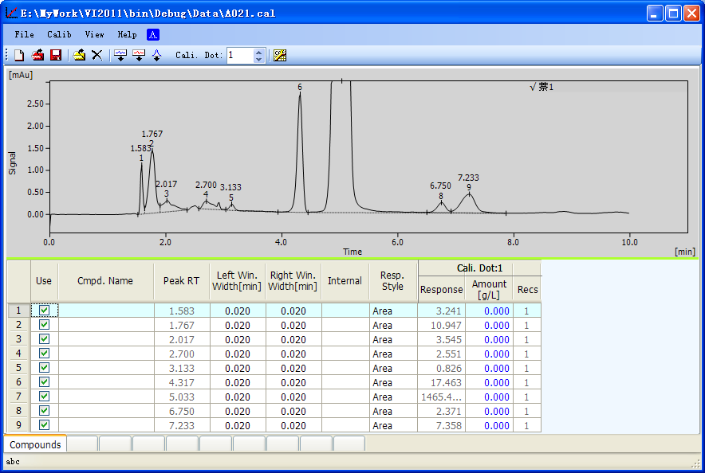

change the Resp. Style to be Area or Height, and input the Amount correspondently.
Open another standard spectra, given the Cali. Dot. To 2 . The first spectra can be closed or reserved. Click , input the Amount correspondently.
Note: if the Resp. Style is 0, please check if the reserve time of spectra 2 is within the spectra 1.
Then open spectra 3, given the Cali Dot To 3. , click, input the Amount correpondently.
Then open spectra 4, given the Cali Dot To 4. , click, input the Amount correpondently

Click “Compounds”in the left botton to see the calibration curve.

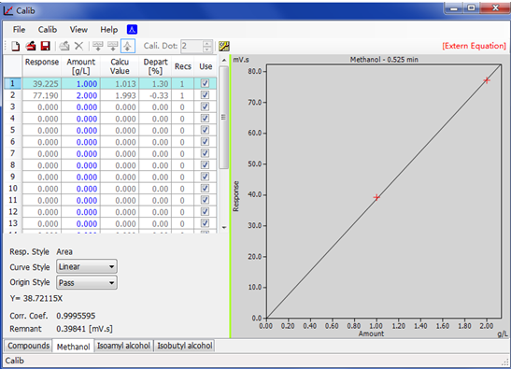

Menu above:

Response: Displayed the response value
Amount: Amount of compounds, which can be input in the table, the unit can be changed by click
Calcu Value: The amount value in the calculation mode
Depart: (calculation value-amount)/amount*100%
Recs: Number of Value which added in the same calibration point.
Use: $√$ means use this point, will be displayed in the curve, if no choice, will be displayed.
Resp. Style: Style can be choosed in this menu
Curve Style: Style can be choosed in this menu
Origin Style: Include three mode:
Ignore: ignore the point (0,0)
Join: join the point (0,0) as a point, which will be used when only one data point
Pass: pass the original point (0,0)
Remnant.: Resp. $\left(\sqrt{\sum_{1}^{n}{{(Resp.Value-Actual Value)}^{2}}}\right)$

7.2 ISTD

The basic step of ISTD is same with ESTD.
Notice: ISTD without equation.

Press to save the calibration file (*.cal).

8.0 Report
